Identification of Unknown B
Tyler Saint
11/28/23
Chem 2081-004

Introduction
The purpose of this report is to identify a compound through the use of nuclear magnetic resonance(NMR) spectroscopy, gas chromatography-mass spectrometry(GCMS), and Fourier transform infrared spectroscopy(FTIR). These are the common tests that are ran to try and identify organic compounds. Being able to determine the compounds present in these spectra will be an essential skill in many careers involving chemistry and other sciences.
Body
NMR is one of the most powerful and widely usable techniques that is used to determine the structures of organic compounds. It is often the only technique needed to identify a compound successfully though for actual determine of the structure employs the use of other techniques. NMR is done through the study of the interactions that occur between electromagnetic radiation and the nuclei of the atoms in the compound. Many different compounds can be studied with it but hydrogen and carbon are the most common. The first NMR spectrometers were continuous wave instruments. The samples were irradiated with a radio frequency and the magnetic fields varied. When there was a match of RF and the energy difference between two spin states of the nucleus there was a signal was detected and that reflected energy reflected the environment of the nucleus. Analysis of these spectra is able to give information about the individual carbon to hydrogen bonds and therefore can give detailed information about the full structure of the compound. A nucleus that has an odd number of protons and/or neutrons have a quantum mechanical property that is called nuclear spin that can be determined with an NMR spectrometer. Though there is not an actual spin it generates a spinning sphere of charge and generates a magnetic field that is called a magnetic moment that could be equated to the magnetic field that is produced by a bar magnet. When hydrogen nuclei are subjected to this external magnetic field the interaction between the field and the magnetic moment is quantized. The moment must either align with or against the field and is then given the either the alpha designation for a proton aligned with the field or beta if it is against the field. The two states do not have the same about of energy and there is a energy difference can be quantified. This is called diamagnetism allows the different protons to absorb different amounts of radio frequency(rf) radiation and is essential to NMR spectroscopy.

Mass spectrometry studies the interaction of matter and an energy other than electromagnetic radiation and is used to determine the molecular weight and formula of the compound. The compound is vaporized and converted into ions that are promptly separated and then detected. This is commonly done through the use of high-energy electrons that vaporize the compounds. This is called electron impact ionization(EI) and generates a intermediate that is both a radical as well as a cation. The mass of the electron that was ejected is so small that it is negligible and the mass determined can would be essentially equivalent to the original molecules mass. Normally this is only useful for the identification of pure compounds meaning that mixtures would have to be completely separated before mass spectrometry can be used. Gas chromatography-mass spectrometer greatly simplified the process by combining gas chromatograph with a mass spectrometer. The mixture is separated by the gas chromatograph which allows the mass spectrometer to analyze in sequence. The gas chromatograph has long, narrow tubes that have viscous, high-boiling liquid on a support that is called the stationary phase. This tube is connected to an oven the allows for precise control of temperature. A syringe is used to inject the mixtures into the gas chromatograph which vaporizes it and mixes it with an inert gas and passed through the tubes. The different compounds pass through at different rates based on their own boiling points and the affinity that they have for the stationary phase. These different compounds have their own unique amounts of time that they take to pass through the gas chromatograph and exit that is called retention time. This allows them to be separated from each other and is plotted on a chromatogram. After the compounds exit the gas chromatograph they are passed through the mass spectrometer in which their molecular weight can be determined.

IR radiation causes vibration of the different bonds that are present in a molecule of which there are different kinds due to the different ways that these bonds store energy. They can bend and stretch, and the bending can be done in a number of different ways. The energy gaps that are present between the vibrational states depends on the nature of the bonds. This means that though the different bonds will absorb the IR radiation, the larger the energy gap between the bonds the higher the energy of the photon it will absorb which allows determination of the types of bonds that are present in the compound. The sample is irradiated with all the different frequencies of IR radiation and the frequency that were absorbed are detected. In an IR spectrometer, the sample is irradiated and the frequency that are able to pass through are detected. This allows a plot that shows which frequency were absorbed to be created allowing identification. The most common type of IR spectrometer that is used is called a Fourier transform(FT-IR) spectrometer. It irradiates the sample with all frequencies of IR radiation simultaneously and a mathematical operation called Fourier transform used to determine the frequencies that passed through and therefore the sample can be properly determined. The preparation of the sample can be done many different ways but a common way is through the use of salt plates. The expensive plates are made of sodium chloride and what is used because they are transparent to IR radiation. The sample is placed between two plates as a liquid and then passed through. Another way that is done with insoluble compounds are mixed with powered KBr and then pressed into a transparent film that is called a KBr pellet.
Data
NMR Sample B
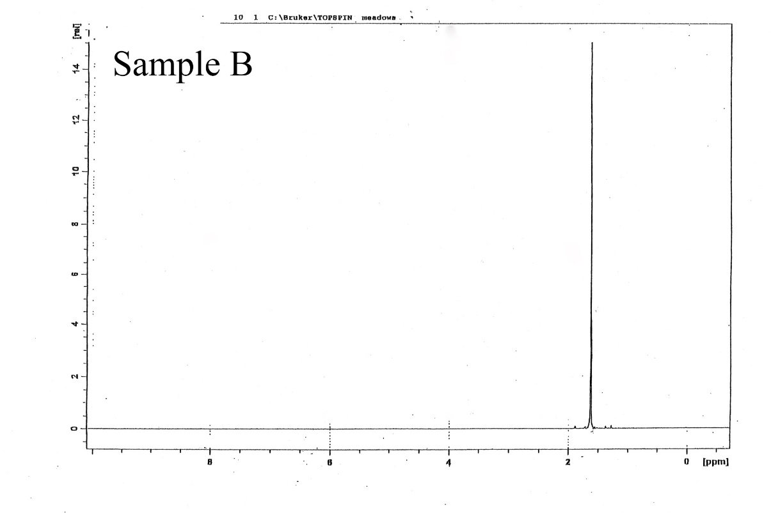

GCMS Sample B
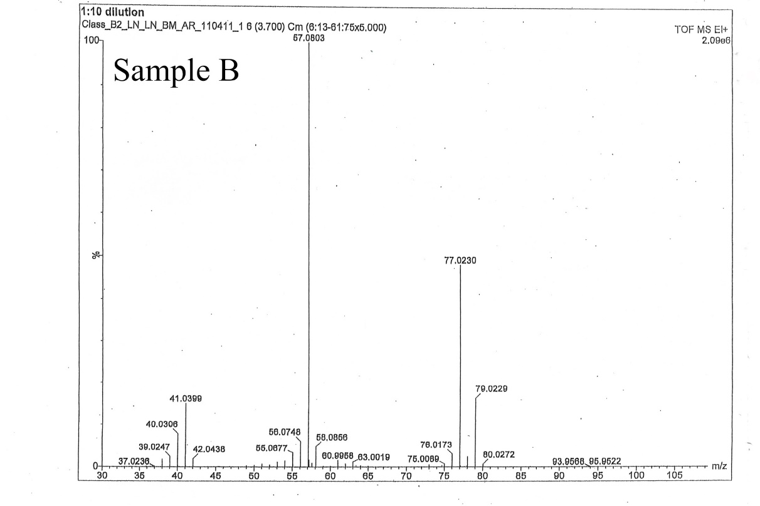

FTIR Sample B
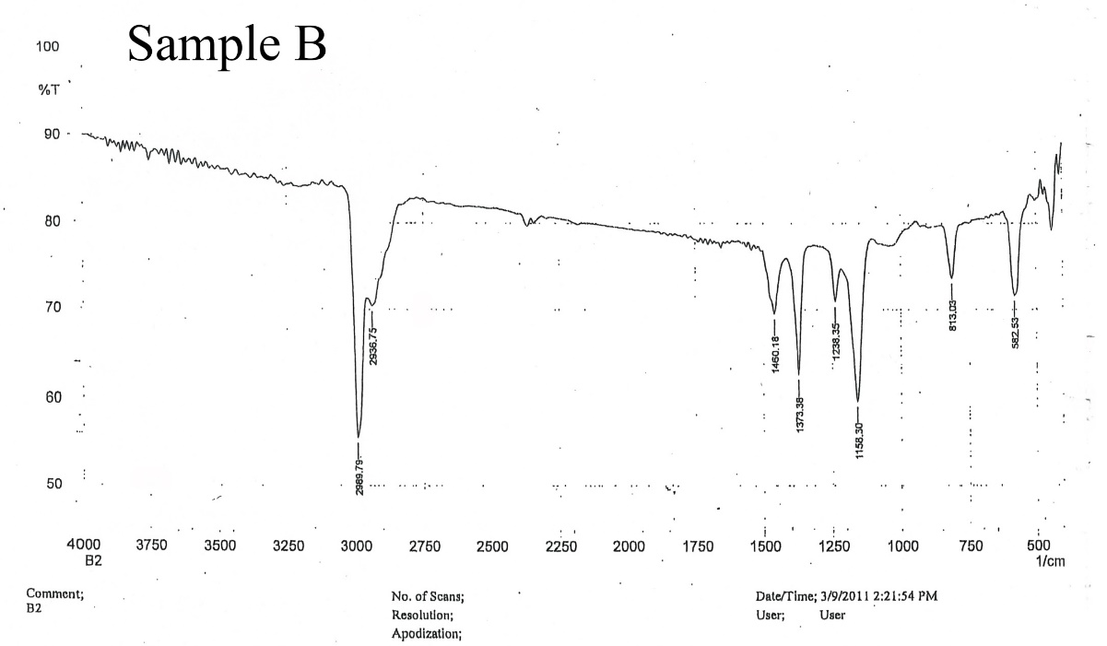

Analysis
The NMR has a peak that is at about 1.8 that indicates there are 9 hydrogens present on 3 carbons which are all methyl protons in the compound. The GCMS graph shows a 100% absorbance at approximately 57 which when using the rule of 13 gives 4 carbons and 9 hydrogen another peak is at 77 with an absorbances of about 38% which indicates a chlorine. The FTIR spectra shows peaks at around 2900 showing the carbon to hydrogen bonds in the compound with one of the footprint peaks around 500 showing the carbon to chlorine bond. The compound being 2-chloro-2-methylpropane also known as tert-Butyl chloride.
Conclusion
Using all the spectra that were given to determine the amount of hydrogens present, the types of bonds present, the functional groups, and the mass of the compound it was determined to be 2-chloro-2-methylpropane or tert-Butyl chloride. All of the spectra line up to indicate that it is the compound present.
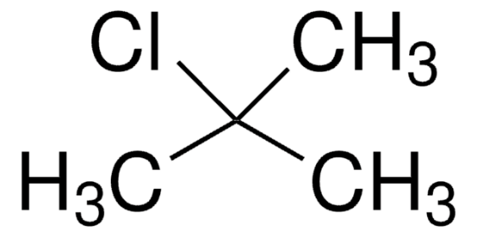

References
Keller L, Joseph K, and Miguel S. 2023 Fall. CHEM 2081 Organic Chemistry 2 Lab Manual [lab manual]. Auburn (Al): Auburn University.
Klein, D. R. Organic Chemistry, 4th ed.; Wiley: Hoboken, Nj, 2021.
AIST:Spectral Database for Organic Compounds,SDBS. Aist.go.jp. https://sdbs.db.aist.go.jp/sdbs/cgi-bin/direct_frame_top.cgi.
‌
‌

